Project 5

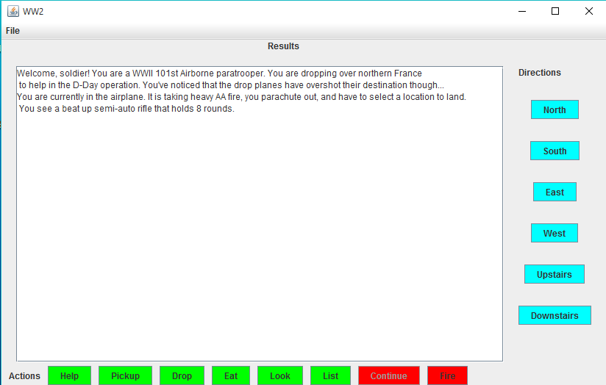Ben Parsell

"I pledge that this work is entirely mine, and mine alone (except for any code provided by my instructor)."

I spent around 20 hours on this project in total smashing bugs and writing/testing my software.

To Win:

g = new Game();

g.pickup("M1 Garand");

g.move("north");

g.fire();

g.continueGame();

g.pickup("Grenade");

g.move("downstairs");

g.fire();

g.continueGame();

g.move("south");

g.move("south");

g.move("east");

g.fire();

g.continueGame();

g.move("south");

g.fire();

g.continueGame();

g.move("east");

g.fire();

g.continueGame();

g.pickup("Radio");

g.move("north");

g.gameOver();

System.out.println(g.getMessage());

========== **SAMPLE OUTPUT** ========

You have picked up M1 Garand

You are currently in a destoryed-interior upstairs to a house. There is a dead

American paratrooper on the floor.

You see a combat-ready soldier trying to kill you..

You killed the enemy. CLICK CONTINUE

You search the enemy body and see something. Pickup Grenade?

You have picked up Grenade

You are currently in You are in the main living room of the farmhouse. There are exits at the front and back-door,

everything else is blocked off..

You see a combat-ready soldier trying to kill you..

You killed the enemy. CLICK CONTINUE

You search the enemy body and see something. Pickup Apple?

You are in The gate to Main Street..

You are currently in a traditional 1940s drug store with a soda bar..

You see a bottle of pills with the prescription label ripped off.

You are currently in a French-style tavern. It's very dark in here....

You see a combat-ready soldier trying to kill you..

You are currently in the hefty german camp..

You see a Panzer Tiger tank loaded and ready to fire..

You failed to kill the enemy, and he shot you in the chest dropping you dead.

**Source Code**

System.out.println("========== Game Playthrough(lose) ========");

g = new Game();

g.pickup("M1 Garand");

System.out.println(g.getMessage());

g.move("north");

System.out.println(g.getMessage());

g.fire();

System.out.println(g.getMessage());

g.continueGame();

System.out.println(g.getMessage());

g.pickup("Grenade");

System.out.println(g.getMessage());

g.move("downstairs");

System.out.println(g.getMessage());

g.fire();

System.out.println(g.getMessage());

g.continueGame();

System.out.println(g.getMessage());

g.move("south");

System.out.println(g.getMessage());

g.move("south");

System.out.println(g.getMessage());

g.move("east");

System.out.println(g.getMessage());

g.move("south");

System.out.println(g.getMessage());

g.gameOver();

System.out.println(g.getMessage());

System.out.println("=========================================");